Task🡪**Migration of Instance from one Region to another Region (Mumbai to Singapore)**

1. **First we will launch EC2 Instance in Mumbai region by name Mumbai-ap-south-1 as below**

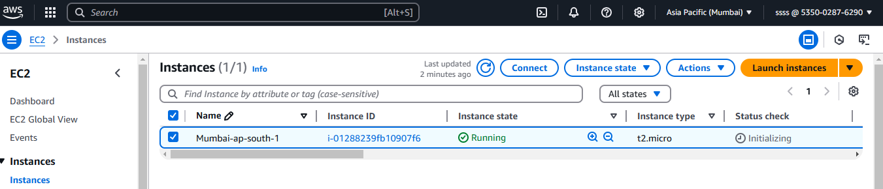

**2.Now we will install Jenkins-🡪we required Git+Java +Docker+ Maven+ Jenkins (atleast java version 17 or 21 is required for Jenkins)**

**2a. Installed Git version as below by Using command--🡪 yum install -y git**

**First run🡪 yum -y update**

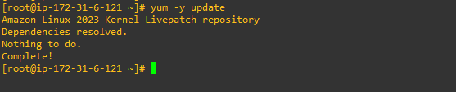

**Installed Git as below** 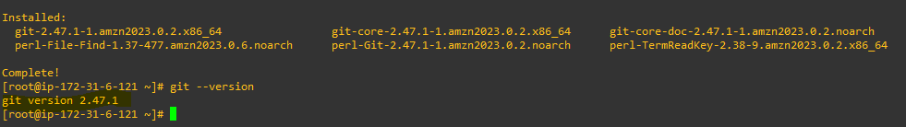

**2b. installed latest java version as below by using command 🡪**

**yum install -y java-17-amazon-corretto**

**yum install -y java-17-amazon-corretto-devel**

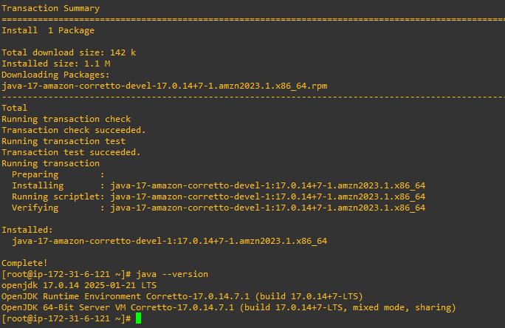

**2c. Installed Docker as below by using command 🡪**

**yum install -y docker**

**service docker start**

**usermod -aG docker ec2-user**

**chkconfig docker on**

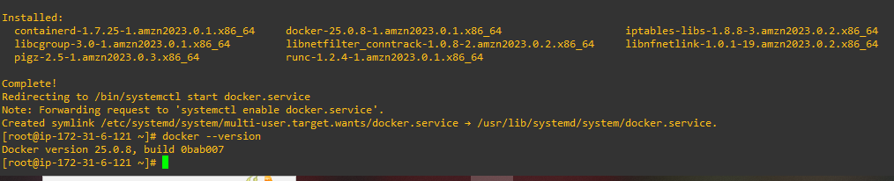

**2d. Installed Jenkins as below by using commands 🡪**

**sudo wget -O /etc/yum.repos.d/jenkins.repo \**

**https://pkg.jenkins.io/redhat-stable/jenkins.repo**

**sudo rpm --import https://pkg.jenkins.io/redhat-stable/jenkins.io-2023.key**

**sudo yum upgrade**

**sudo yum install-y fontconfig java-17-openjdk**

**sudo yum install -y jenkins**

**sudo service jenkins start**

**sudo systemctl daemon-reload**

**chkconfig jenkins on**

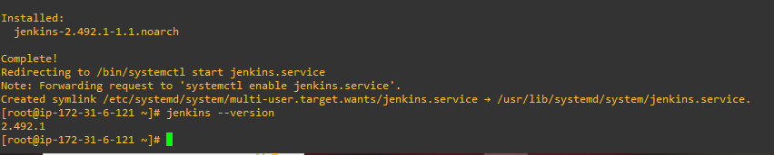

**3.We will modify the security group inbound port to 8080 as Jenkins will run on 8080 port as below**

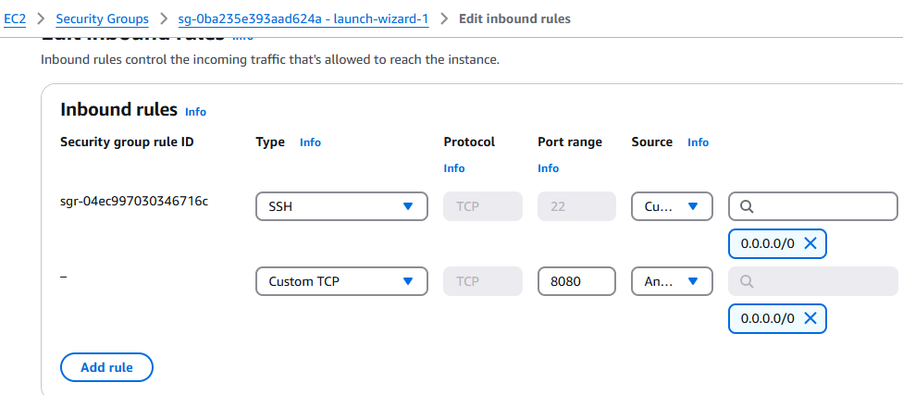

**4.BY using public IP address and port 8080 we will run the Jenkins**

**IP address--3.110.224.248 :8080**

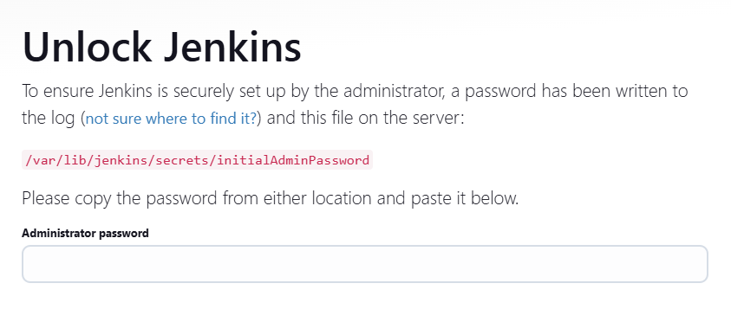

**Note -By using this command we will get password to login Jenkins**

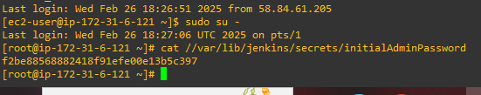

**5.Jenkins will install further Plugins after clicking install suggested plugins**

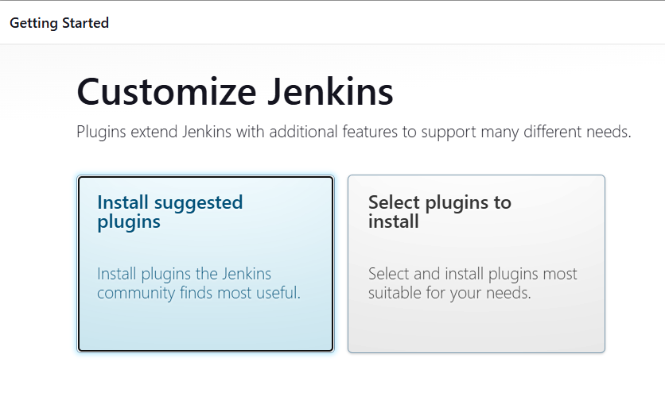

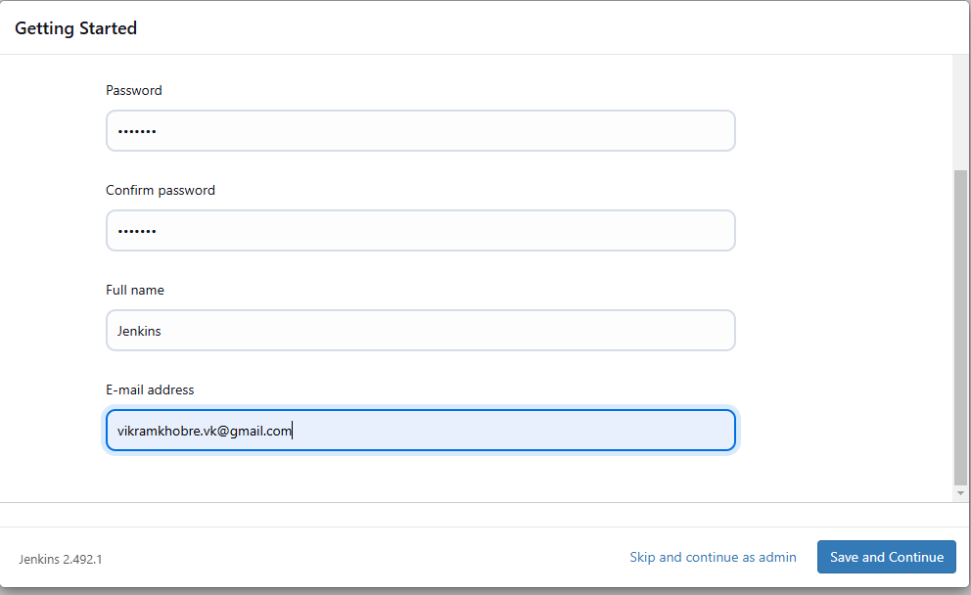

**6.By clicking Save an continue you will get Jenkins ready**

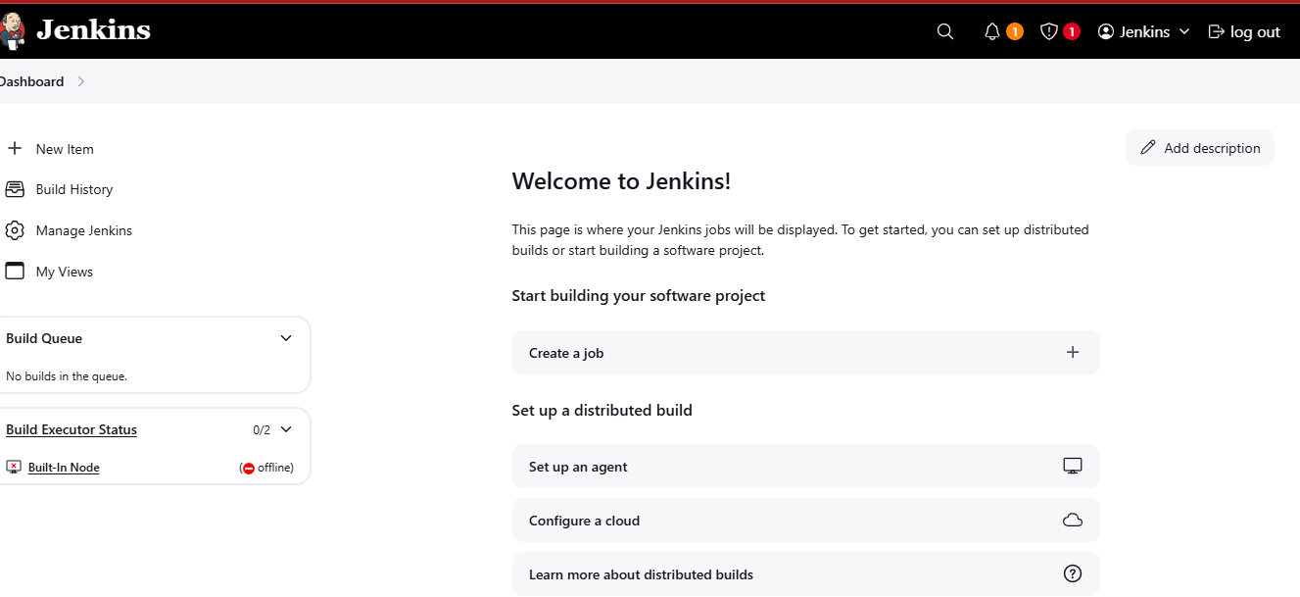

**7.Now we will create a snapshot of Volume in Mumbai Region as below**

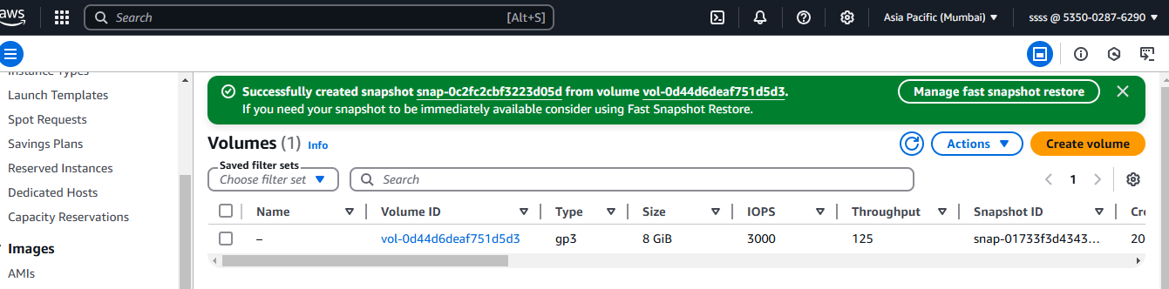

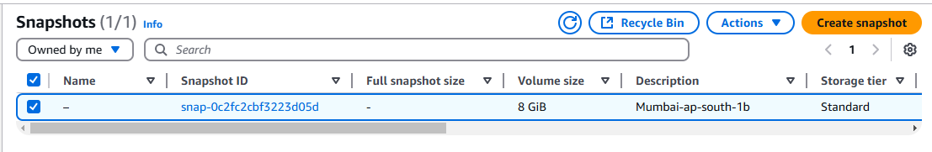

**8.Now copy the snapshot in singapore region as below**

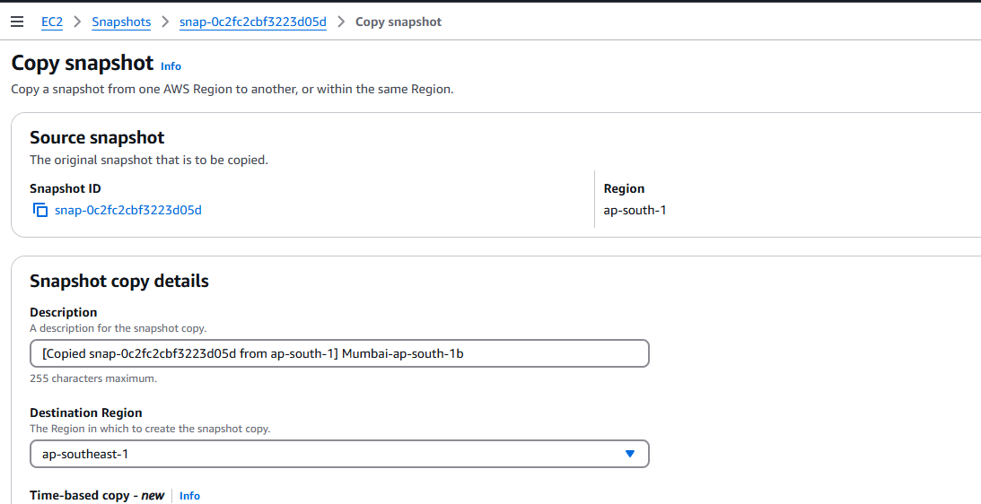

**9. Create another instance in Singapore region and providing all the security group Inbound port to 8080 as well**

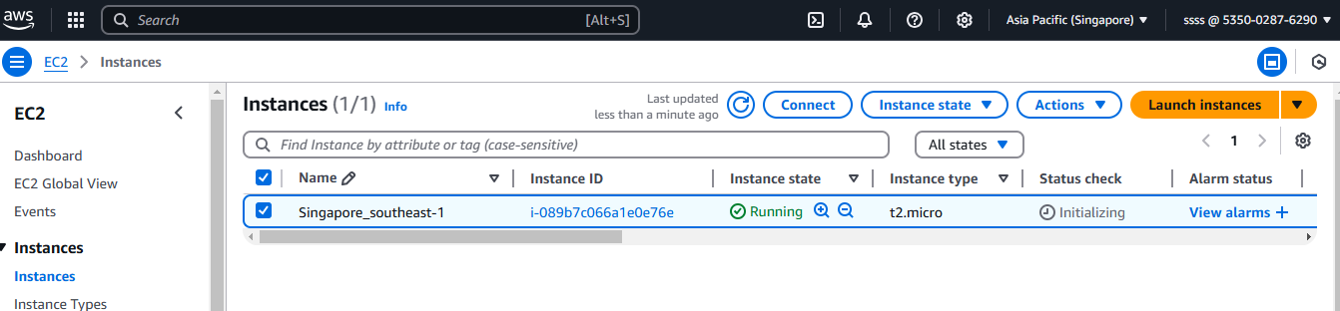

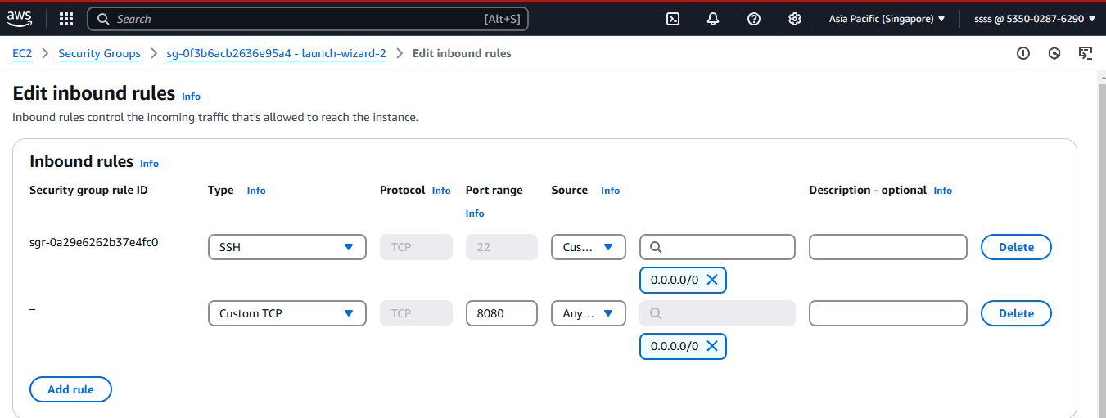**10.Now we will be stop the Instance of Singapore region to detach Root EBS volume**

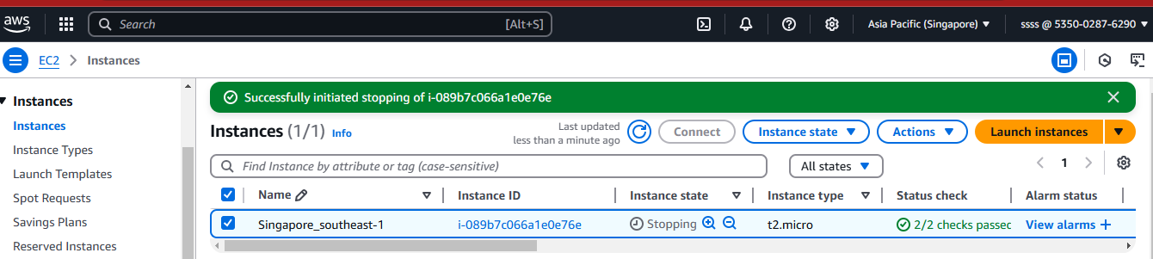

**11. Root EBS Volume has been detached as below**

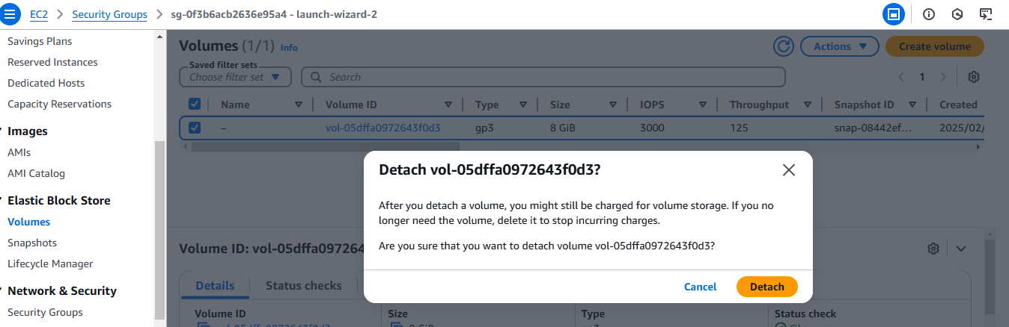

**12.Now we will attach migrated volume from Mumbai to Singapore region**

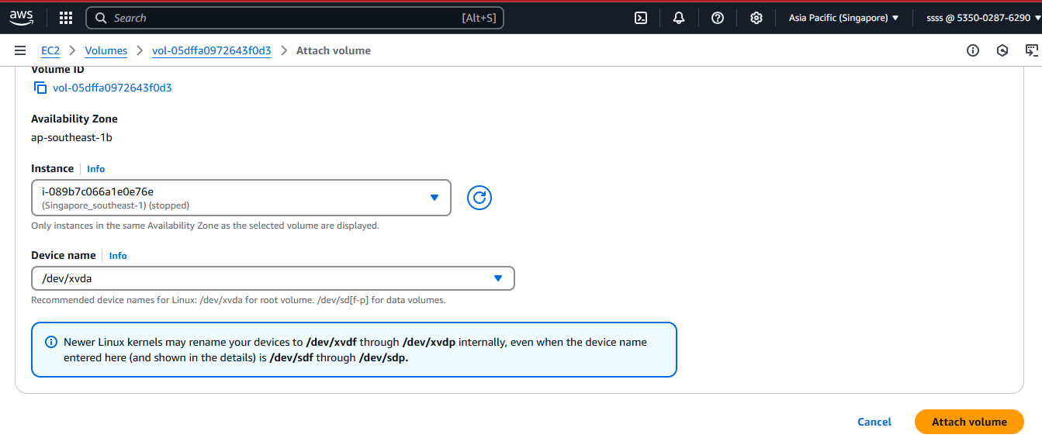

**13.Now we will start the instance and you will see Volume has been successfully migrated in Singapore region**



**14.Now tried to login Jenkins via Singapore region as below**

**Jenkins is running in both the regions**

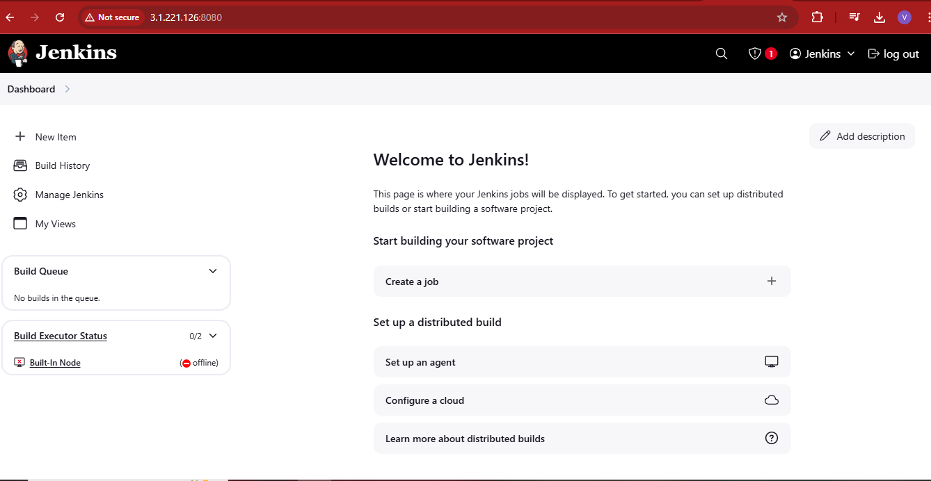

**Mumbai region Jenkins**

